**Windows Subsystem for Linux (WSL)**

Simply go to the Microsoft store and search for, download and install Ubuntu

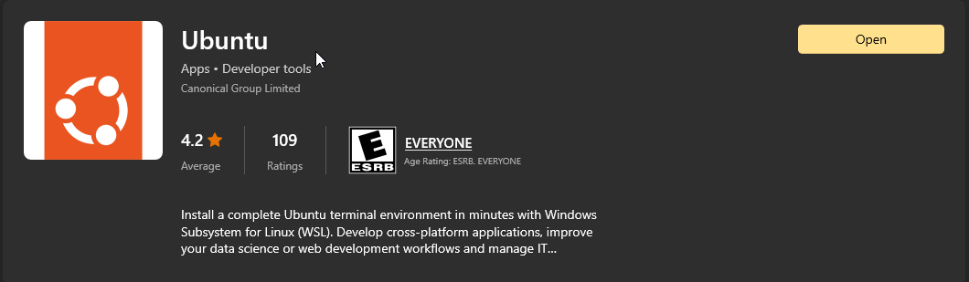

Search for Ubuntu in the start menu and open the app to access the linux terminal.

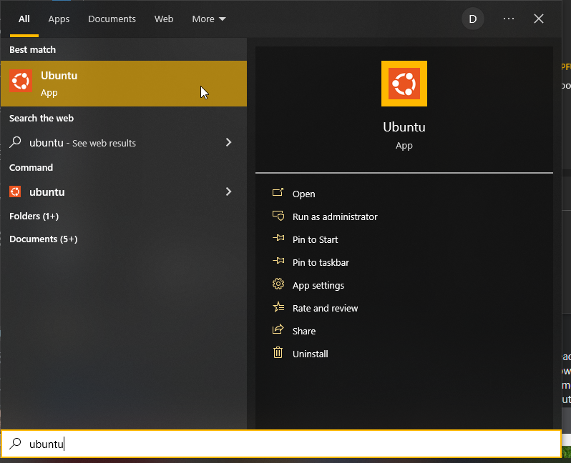

To make the Linux Challenge files accessible in Ubuntu, run the ‘explorer.exe .’ command.

This will open a Windows file explorer window where you can then copy and paste the downloaded Linux challenge folder.

